MC Practicles
Exp1 CDMA
Code:-
import numpy as np
c1=[1,1,1,1]
c2=[1,-1,1,-1]
c3=[1,1,-1,-1]
c4=[1,-1,-1,1]
rc=[]
print("Enter the data bits :")
d1=int(input("Enter D1 :"))
d2=int(input("Enter D2 :"))
d3=int(input("Enter D3 :"))
d4=int(input("Enter D4 :"))
r1=np.multiply(c1,d1)
r2=np.multiply(c2,d2)
r3=np.multiply(c3,d3)
r4=np.multiply(c4,d4)
result_channel= r1+r2+r3+r4;
print("Resultant Channel", result_channel)
Channel=int(input("Enter the station to listen for c1=1,c2=2,c3=3,c4=4 :"))
if Channel==1:
rc=c1
elif Channel==2:
rc=c2
elif Channel==3:
rc=c3
elif Channel==4:
rc=c4
inner_product=np.multiply(result_channel,rc)
print("Inner Product", inner_product)
res1=sum(inner_product)
data=res1/len(inner_product)
print("Data bit that was sent", data)

EXP 3 BER

Code:-

clear all;
close all;
clc;

% Simulation Parameters
M = 2; % BPSK
Eb_N0_dB = 0:60; % SNR in dB
Eb_N0 = 10.^(Eb_N0_dB/10); % SNR
N = 10000; % number of bits

% BPSK Modulation
x = rand(1,N)>0.5; % random bit stream
y = 2*x - 1; % BPSK modulation

% Rayleigh Fading Channel
h = (randn(1,N) + 1i*randn(1,N))/sqrt(2); % Rayleigh fading channel

% Initialize BER
BER = zeros(1,length(Eb_N0_dB));

% Simulation
for ii = 1:length(Eb_N0_dB)
% Add noise
n = (randn(1,N) + 1i*randn(1,N))/sqrt(2)*sqrt(1/(2*Eb_N0(ii)));
r = h.*y + n; % received signal

% Demodulation
r_det = real(r) > 0; % decision detector

% Calculate BER
BER(ii) = sum(xor(x,r_det))/N;
end

% Plot BER vs SNR
semilogy(Eb_N0_dB,BER,'-o');
grid on;
xlabel('SNR (dB)');
ylabel('BER');
title('BER vs SNR for BPSK over Rayleigh Fading Channel');

Cisco packet configuration

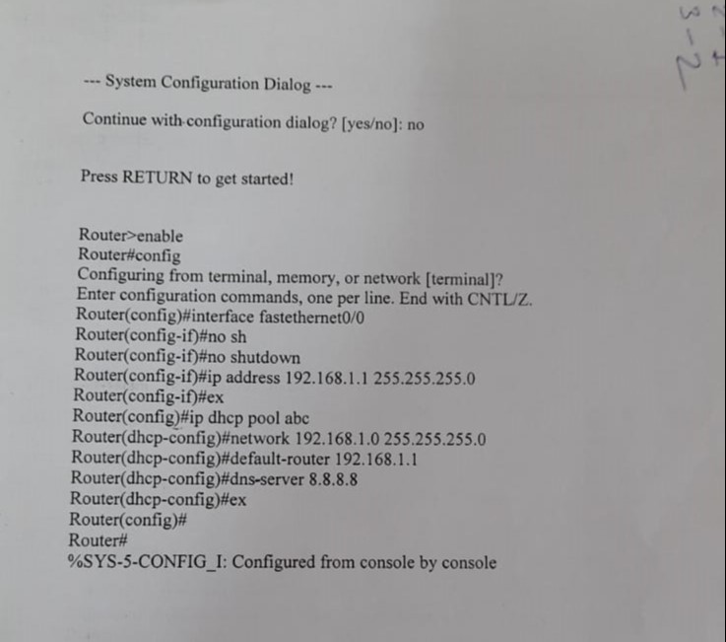

Exp 7 File Transfer
Server.py
Code:-
import socket

HOST=socket.gethostbyname(socket.gethostname())
PORT=4455

with socket.socket(socket.AF_INET,socket.SOCK_STREAM) as s:
s.bind((HOST,PORT))
s.listen()
print("server listing on",HOST,"port",PORT)
conn,addr=s.accept()
print("connected by ",addr)
with open(“file_to_send”,"rb") as f: #file location
while True:
data=f.read(1024)
if not data:
break
conn.sendall(data)
print("File send successfully")

Client.py
Code:-

import socket

#HOST='192.168.2.104'
HOST=socket.gethostbyname(socket.gethostname())
PORT=4455

with socket.socket(socket.AF_INET,socket.SOCK_STREAM) as s:
s.connect((HOST,PORT))
with open("received_file","wb") as f: #file location
while True:
data=s.recv(1024)
if not data:
break
f.write(data)
print("File Received successfully")

